Enterprise pro – meeting notes

**Adam Akhtar** **–** 23008644, **Ahmed Ali –** 23018761, **Ahmed Qadoura –** 23019360, **Haris Mahmood –** 23012399, **Shabbir Mohammad Ahmad –** 23015739, **Shamas Hussain –** 22007269, **Zeshan Raja Hussain –** 22008836.

**Meeting notes**

**Title –** 30 Minutes in person**.**

**Date –** Monday 3rd February.

**Participants –** Adam Akhtar, Ahmed Ali, Ahmed Qadoura, Haris Mahmood, Shabbir Mohammad Ahmad, Shamas Hussain and Zeshan Raja Hussain.

**Content –** Our team will be doing project five which is the Job Advertisement Portal. The aim for today’s meeting is planning and roles. First task will be to choose a team leader, secretary, and team speaker. As a team, we have selected the team leader, secretary, and team speaker. The plan for the next meeting is to see the client and find out the requirements. Once we find out the requirements from the client in the next meeting, we can then start allocating tasks to each team member.

Roles

**Team leader –** Adam Akhtar 23008644

**Secretary –** Shamas Hussain 22007269

**Team speaker –** Zeshan Raja Hussain 22008836

**Meeting notes**

**Title –** In person with client 3:20pm till 3:45pm.

**Date –** Tuesday 4th February.

**Participants –** Adam Akhtar, Ahmed Ali, Ahmed Qadoura, Haris Mahmood, Shabbir Mohammad Ahmad, Shamas Hussain, Zeshan Raja Hussain and client (Szymon Smolen).

**Content –** Our aim for today’s meeting is to see the client, find out the functional and non-requirements. In the meeting, the client told us the pages required on the website for the job advertisement. The website will need a main page, search bar page, login page, payment page, add me portal page and signing up page. Profiles for individual users should include name/surname/email/phone number/age and location. Customers should be able to contact the creator of the websites as well as the people listing the job in case, they have any questions or need help, and one step verification should be considered to verify user by email (sending a code). Nonregistered users can only view jobs, and no applications can be made, nor can they make any listings. The plan for the next meeting is to allocate tasks to all the team members and create GitHub accounts.

Pages in order

Signup / login page.

Dashboard page.

Admin portal.

SQL database.

Functionality.

Front end design.

Other things to consider on the website for the job advertisement.

Everything should be a basic design and not complicated.

Can choose any language.

Users apply for jobs post jobs.

People from other places or country should be able to apply and area filer does not have to be too specific.

Ratings and reviews should be visible.

Data security should be considered.

Customer includes if want budget.

Payment system should be their payment website bitcoin and PayPal.

Customers get verified through email or phone number.

Notification sent when job is accepted.

To communicate email bubble chart.

Three acters and small jobs only.

Customers include pie texture and title optional project.

For main page could add pictures and use different fonts.

Welcome back page (Login page).

Create account page.

Add me portal page.

Search bar page (Apply for job).

Payment page.

**Meeting notes**

**Title –** 45 Minutes over the phone.

**Date –** Friday 7th February.

**Participants –** Adam Akhtar, Ahmed Ali, Ahmed Qadoura, Haris Mahmood, Shabbir Mohammad Ahmad, Shamas Hussain and Zeshan Raja Hussain.

**Content –** The aim for this meeting is to assign roles and tasks to all the team members. In addition, everyone in the team will be creating GitHub accounts before the end of the meeting. As a team, we have now allocated tasks to all the members in the team. The aim for the next meeting is for everyone to have started the assigned tasks.

Assigned Roles

|  |
| --- |
| Adam Akhtar – 23008644 |
| Adam has been assigned with the SRS document, prototype and organising team meetings. In addition, Adam contributed with creating the backend SQL database and adhering to the clients’ requirements. |

|  |
| --- |
| Ahmed Ali **–** 23018761 |
| Ahmed Ali has been assigned with the SDD document, prototype and the backend JavaScript using NodeJS as the framework. |

|  |
| --- |
| Ahmed Qadoura – 23019360 |
| Ahmed Qadoura has been assigned with the SDD document, prototype and contributed with creating the frontend of the website. This included working with react and contributing to CSS and html. |

|  |
| --- |
| Haris Mahmood – 23012399 |
| Haris has been assigned with the SRS document, prototype and Gannt chart. Furthermore, Haris contributed to the functional aspects of the website using JavaScript and the react framework. |

|  |
| --- |
| Shabbir Mohammad Ahmad – 23015739 |
| Shabbir has been assigned with the SRS document, prototype and contributed to the front-end development of the website which included aspects such as user functionality. |

|  |
| --- |
| Shamas Hussain – 22007269 |
| Shamas has been assigned with the SDD document, prototype, keeping up with team minutes, team notes and documentation. Furthermore, Shamas was overlooking the updates from the team and getting everything onto GitHub. |

|  |
| --- |
| Zeshan Raja Hussain – 22008836 |
| Zeshan has been assigned with the SDD document, prototype, Gannt chart and the sketch of the use case diagram. |

**Meeting notes**

**Title –** Two hours in person.

**Date –** Tuesday 11th February.

**Participants –** Adam Akhtar, Ahmed Ali, Ahmed Qadoura, Haris Mahmood, Shabbir Mohammad Ahmad, Shamas Hussain and Zeshan Raja Hussain.

**Content –** The aim for the meeting is to check if everyone in the team has GitHub accounts and to make a start on the assigned roles. In today’s meeting we discussed the use case diagram, prototype, sign-up page, log in page. During today’s meeting, we made a start on the prototype, sign up page, log in page, use case diagram, the SRS and SDD documents. In the next meeting we will be carrying on with the tasks. Furthermore, the aim for the next meeting is to see how everyone is doing in the assigned tasks and help each other as a team where required.

Things discussed in the meeting to consider.

Think about functionality.

Think about features for the sign – up page and log in page.

Think about pages.

Think about the users.

Think about jobs, listed jobs, office jobs and how many there going to be.

Look at existing sites.

Do a sketch of the use case diagram.

Bisector, expand and interface.

**Meeting notes**

**Title –** 35 minutes over the phone.

**Date –** Thursday 13th February.

**Participants –** Adam Akhtar, Ahmed Ali, Ahmed Qadoura, Haris Mahmood, Shabbir Mohammad Ahmad, Shamas Hussain and Zeshan Raja Hussain.

**Content –** The aim for the meeting is to continue with the tasks, to see how everyone is doing in the assigned tasks and help each other as a team where required. In today’s meeting we went through the prototype, SDD and SRS documents. The aim for the next meeting is to have all the tasks completed and ready to submit.

|  |  |  |  |
| --- | --- | --- | --- |
| Gannt chart | Prototype | SDD document | SRS document |
| Haris Mahmood  Zeshan Raja Hussain | Adam Akhtar  Ahmed Ali  Ahmed Qadoura  Haris Mahmood  Shabbir Ahmad  Shamas Hussain  Zeshan Raja Hussain | Ahmed Ali  Ahmed Qadoura  Shamas Hussain  Zeshan Raja Hussain | Adam Akhtar  Haris Mahmood  Shabbir Ahmad |

**Meeting notes**

**Title –** 2 hours in person.

**Date –** Tuesday 18th February.

**Participants –** Adam Akhtar, Ahmed Ali, Ahmed Qadoura, Haris Mahmood, Shabbir Mohammad Ahmad, Shamas Hussain and Zeshan Raja Hussain.

**Content –** The aim for this meeting is to have all the tasks completed and ready to submit. Throughout today’s meeting we worked on the coding, SDD and SRS documents which is almost ready to be sent off and continued working on the prototype that is almost complete as well. In addition, we discussed the sign-up page and that is almost done. The aim for the next meeting is to have the coding, SDD and SRS documents sent off.

|  |  |  |
| --- | --- | --- |
| Coding | SDD | SRS |
| Signup / login page. | Introduction. | Planning and roles. |
| Dashboard page. | Database design document. | Functional requirements. |
| Admin portal. | Backend implementation. | Non-functional requirements |
| SQL database. | Front end design. | Ethical functional concerns. |
| Functionality. |  | Final draft. |
| Front end design. |  |  |

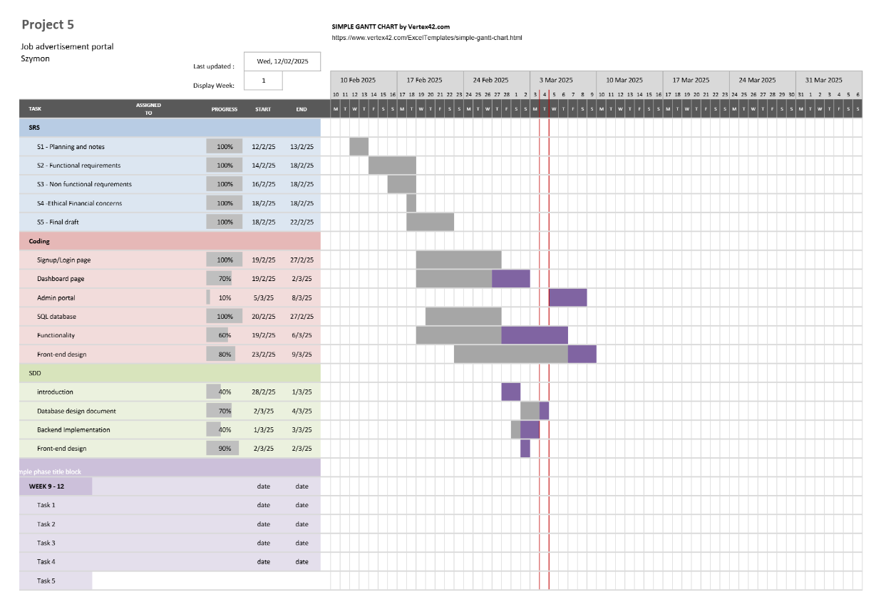Gannt chart

**Meeting notes**

**Title –** 2 hours in person.

**Date –** Tuesday 25th February.

**Participants –** Adam Akhtar, Ahmed Ali, Ahmed Qadoura, Haris Mahmood, Shabbir Mohammad Ahmad, Shamas Hussain and Zeshan Raja Hussain.

**Content –** The aim for the meeting is to have the coding, SDD and SRS documents sent off and to get everyone in the team to submit on GitHub.

Team statements

**Adam Akhtar –** has been assigned with the SRS document, prototype and organising team meetings. In addition, Adam contributed with creating the backend SQL database and adhering to the clients’ requirements. Furthermore, Adam played a role in updating the SQL database as well as updating the JavaScript page for ‘Appjs.’

**Ahmed Ali** **–** has been assigned with the SDD document, prototype and the backend JavaScript using NodeJS as the framework. In addition, Ahmed Ali helped create the register, login, and dashboard pages using html as well as JavaScript logic.

**Ahmed Qadoura –** has been assigned with the SDD document, prototype and contributed with creating the frontend of the website. This included working with react and contributing to CSS and html.In addition, Ahmed Qadoura submitted part of the SQL database in collaboration with Haris. Furthermore, Ahmed helped with the dashboard, register and login pages.

**Haris Mahmood –** has been assigned with SRS document, prototype and Gannt chart. In addition, Haris contributed to the functional aspects of the website using JavaScript and the react framework. Furthermore, Haris submitted part of the SQL database and worked on the Gannt chart in collaboration with Zeshan.

**Shabbir Ahmad –** has been assigned with the SRS document, prototype and contributed to the front-end development of the website which included aspects such as user functionality. In addition, Shabbir submitted the ‘SRS’ document to GitHub (in collaboration with Adam and Haris).

**Shamas Hussain –** has been assigned with the SDD document, prototype, keeping up with team minutes, team notes and documentation. In addition, Shamas was overlooking the updates from the team and getting everything onto GitHub. Furthermore, Shamas submitted part of the JavaScript pages on the code as well as helping with the index.html page.

**Zeshan** **Raja Hussain –** has been assigned with the SDD document, prototype, Gannt chart and the sketch of the use case diagram. In addition, Zeshan made the majority of server.js page and functions within it. Furthermore, Zeshan worked on the Gannt chart and the SDD document.